­­



Submitted to

:

Sir.Asim Rehan

***BS***

***-***

***Software Engineering***

***3***

***rd***

***-***

***E***

Title: Assignment 2

DSA

Hamza Mehmood

Roll# SP-21-110

NUML

-

S21

-

2352

9



**National University of Modern Languages**

Q1.  You have to search a word from the text and display how many times the word occurs in the text. You will show the Frequency and the Location of that word. Write a paragraph of your own choice in a notepad file and read the text from that file and apply your searching algorithm.

**CODE**

#include <iostream>

#include <fstream>

#include <string>

 #include <cstring>

using namespace std;

int main ()

{

  ifstream MyFile("Hamza_Mehmood.txt");

char str[1000];

int wordCount=0;

string text;

  getline(MyFile, text );

  MyFile.close();

  for(int i=0;i<text.length();i++){

    str[i] = text.at(i);

  }

    char word[1000];

    int i, j, found;

    int strLen, wordLen;

   cout<<"Enter Word To Search For"<<endl;

    cin>>word;

    strLen  = strlen(str);

    wordLen = strlen(word);

    for(i=0; i<strLen - wordLen; i++)

    {

        found = 1;

        for(j=0; j<wordLen; j++)

        {

            if(str[i + j] != word[j])

            {

                found = 0;

                break;

            }

        }

        if(found == 1)

        {

            cout<<word<<" is found at index "<<i<<endl;

            wordCount++;

        }

    }

    cout<<"Occurrence of Words Are "<<wordCount;

    return 0;

}

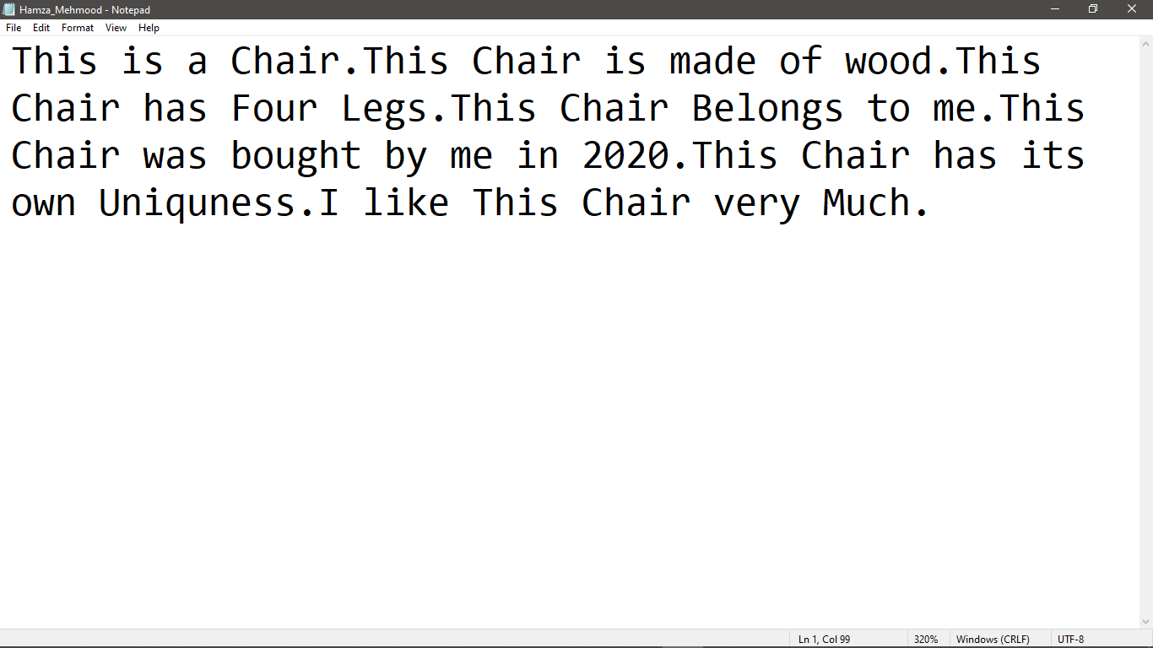 **WORD FILE**

**OUTPUT**

